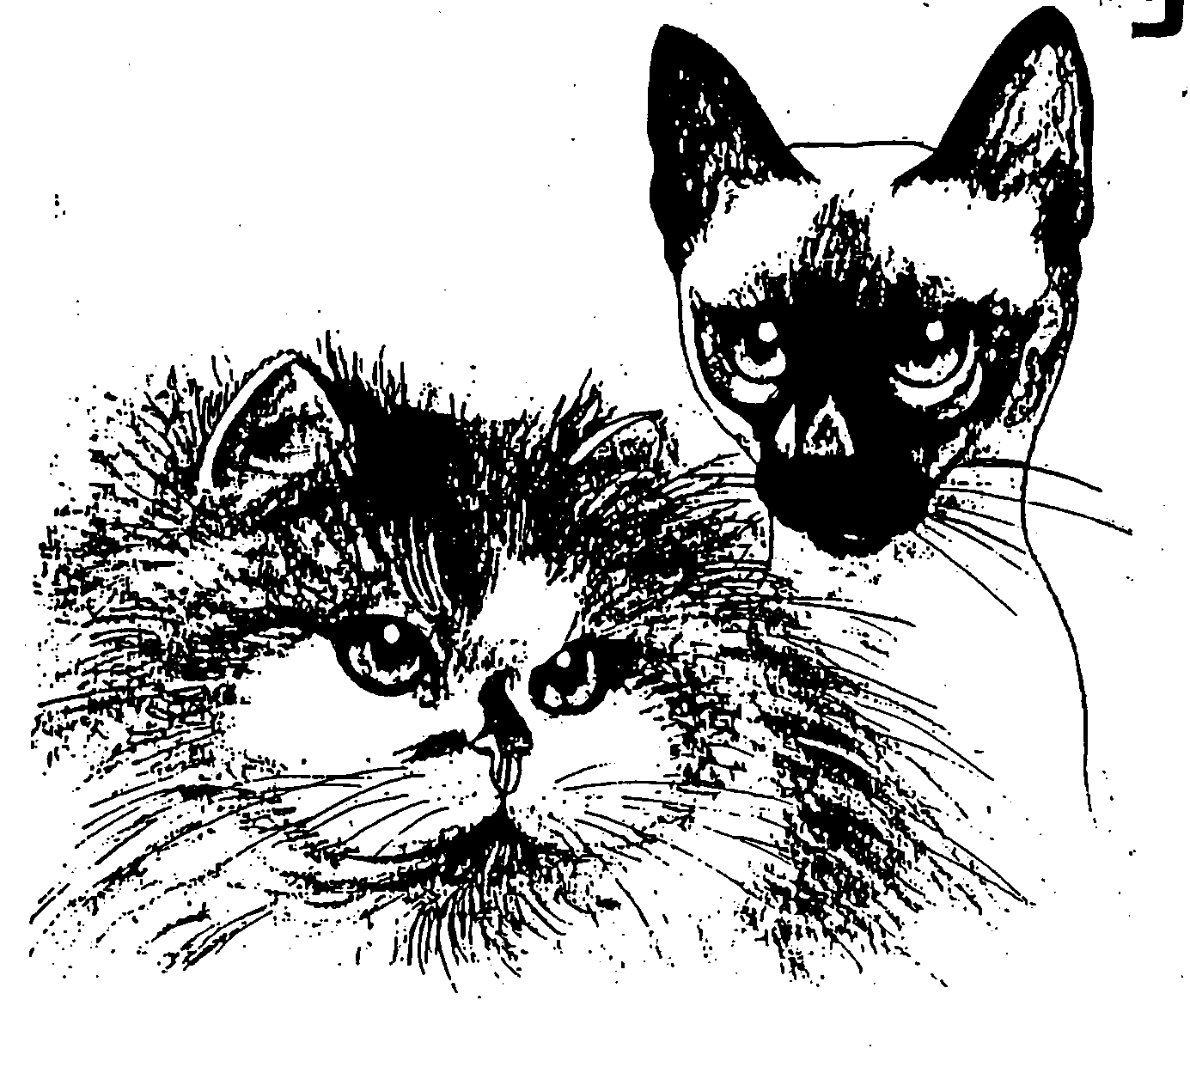

Arr.. OSLO RASEKATTKLUBB

Rasekattutstilling
Solberg Sport og kultursenter
13 og 14 Juni 2015

Åpningstider: kl. 10.00 - 16.00

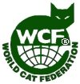
RESULTATKATALOG

* WCF – Show licensing management – Germany *
* WCF - 27 YEARS OF GREAT SHOWS IN ALL 6 CONTINENTS!!!*

Drammen - Norway
WCF Show Licensing
Date: June 13 - 14, 2015

Issue 2: Gelsenkirchen, 2015-06-10
Issue 1: Gelsenkirchen, 2015-04-27
1st application: 2015-04-24

License L# 154127 - EUROPE CONTINENT SHOW – EUR-020
C-9835, C-9836

To: Oslo Rasekattklubb (ORKK)
Att.: Anne Hoffsbakken

Dear President(s),
This license is to give you the right to hold the show listed below once it is licensed under WCF Show Rules
and regulations.
No American rings, for whatever purpose, are allowed in WCF shows, only WCF-rings.
See approved rules for that purpose.
Club(s): ORKK (NO-0238)

Sub-club(s): -----
WCF Rings

Special shows: ---

Judges:
Tomas Balchiunas, Lithuania (AB, WCF)
Vija Klucniece, Latvia (AB, WCF)
Andreas Kretschmer-Kraiczek, Germany (AB, WCF)

Note:
It is not allowed to add any judge, not listed in this license, and no other judge, for whatever purpose, is allowed
to judge on this exhibition.

Monopedigree rings are generally not permitted, any wins will not be recognized.
You may organize special breed shows. These special breed shows are not permitted to be called "ring" or to be performedas ring.
The only rings, which you are permitted to perform, are the 3 WCF-rings as defined in the Show Rules.
All other rings need the permission of the office.
You can make a separate Best in Show for specific breeds, which must be made according to the rules for the BIS.
The winners of the BIS for the 4 categories and the winners of the BIS of special shows are allowed to participate
in the Best of Best.

Please remember to place on stage a large WCF symbol and print this license on one of the first pages of the show catalogue.
Only exhibitions with licenses printed in the show catalogues prove they are really licensed and valid for WCF awards.

ALL SHOWS MUST BE LICENSED and licenses must be printed in the show catalogues.
Each show catalogue must include a page for the WCF, including the names and addresses of the actual Board-members.
In all World and International Shows with foreign judges or exhibitors, all announcements and cat calls during the show and Best in Show ceremonies, MUST BE made also in English, not only in the native language of the country.
In WCF exhibitions cats cannot be judged more than once per day even in combined exhibitions with two or more WCF-clubs, under penalty of rules.

An electronically copy of this show catalogue with all results must be sent to the Chairman of the Show Commission, presently Mrs. Svetlana Sivitskaya and additional to the mail address wcf.showcatalogs@yahoo.de, latest 10 days after the date of exhibition.

The club will face disciplinary actions, and at least a fine of Euro 200.- will apply if the club does not comply with these resolutions.

In addition, we want to remind you of the following important points:
A change of the place or the date requires new C-numbers.
If you need to invite other judges please send the amended show-application at least 6 weeks before the date of the exhibition.

This license will become invalid with suspension or expulsion of the requesting club. Likewise, it loses its validity for non prolongation of patronage.

We from the Board wish you all the best for this upcoming show.

Best regards
WCF show licensing management
Gisela Danisch

*WCF is a registered trademark of World Cat Federation. Its use by non-members will result in prosecution.

WCF-Styrelse/WCF Board WCF Clubs in Scandinavia

President  Mrs Anneliese Hackmann  Geisbergstr. 2, D-45139 ESSEN, Tyskland  email: wcf@wcf-online.se  Generalsekreterare  Andreas Möbius  Hamburger Chausse 23,  D-16559 NEUHOLLAND-LIEBENWALDE (1)  email: browebsite@yahoo.de  t.f. Kassör trasurer  Orjet Drößler  Wichernstr. 6, DE-57074 SIEGEN, Tyskland  email: treasurer@wcf-online.de, wcf.trasurer@gmail.com  1a vice president /1s vice president  Mr Paulo Ruschi  31-70 38th Street, Astoria  US NY-11103 NEW YORK, USA  email: pruschi@nyc.rr.com  2a vice president /2nd vice president  Mrs Tatjana Černova  Hapsalas 15-31, LV-1005 RIGA, Lettlant  email: mrscernova@inbox.lv  Utställningskommitté / Show commission  Mrs Svetlana Sivitskaya  bulv. U.Pobedonosceva 4, corp. 3. apt 108  UA-26023 POLTAVA, Ukraina  email: s_sivitskaya@rambler.ru  Disciplinary Commission/Disciplinary commission  Aleksander Cierpisz (delegated by the Board) PL-52-204 Wroclaw, Polen  email: wcf.disciplinary.commission@gmail.com email: aleksander.cierpisz@gmail.com  Standard- och domarkommtté /  Standard and judge's committé  Mrs Cornelia Hungerecker  Overbergstr. 34, DE-45141 ESSEN  email: c_hungerecker@yahoo.de | Sveriges Nya Raskattförening – SNRF - www.snrf.org  ordf: Wiveca Fransson 08-591 492 74  email: wi.fra@telia.com  sekr.: Sirkka-Liisa Lundbergs 018-25 02 65  email: sekreterare.snrf@comhem.se  SNRFs dotterföreningar:  Föreningen Storstockhomskatten – FSK  ordf.: Leif Dollert 070-022 31 41 email: vagens@comhem.se  Stjärnkattens Raskattförening – STJR  htt://www.stjarnkatten.se/  ordf.: Rose-Marie Kvillert 073-073 31 23  email: loreleis1984@hotmail.com  sekr Gun Gullberg 031-15 68 51 e-post: gun.gullberg@telia.com  WCF-förening i Norge  Oslo Rasekattklubb – ORKK  www.http://home.no/orkk  ordf: Anne Hoffsbakken +47 95 92 93 69  email: godis2@online.no  sekr: Wibekke Berge 0047 95 76 80 62  E-mail: wibekke_berge@yahoo.no  Föreningen Slottskatten - Nybildad förening  www.slottskatten.se  ordf.: Björn Aniansson 0763-41 84 87  email: slottskattenordforande@gmail.com  sekr.: Michaela Karlsson 0738-10 99 80  email: slottskattenwebmaster@gmail.com  WCF.NORDIC.SE  är gemensam hemsida för föreningarna inom samarbets-formen Nordic Cat Clubs of WCF eller WCF-föreningarna i Norden  Övriga WCF-föreningar i Skandinavien:  Föreningen Hallandskatten – FHK  www.hallandskatten.com  ordf.: Ann Öberg 0340-430 06  email: ann.oberg@ipbo.se  Kustkatten – KKN  ordf: Anita Salo 073-70 44 489  email: demitos01@hotmail.com

DOMMERFORDELING

Lørdag 13 juni

Mrs Vija Klucniece | Mr Tomas Balchiunas | Mr Andreas Kretschmer-Kraiczek
PER Solid  PER Tabby  NFO Agouti  Bengal  Siames  Huskatt | EXO  PER Hvitflekk  PER sølv  Britt LH  VET SLH  Maine Coon  Scottish Fold SLH  ULV  Oriental KH  Scottish Fold KH  Burma | LH Vet  NFO NonAgouti/hvit  Non Agouti  Agouti/hvit  Ragdoll  Hellig Birma  Oriental LH  Balines  Shynx  Bambino  Devon Rex  Brittisk KH  Scottish Straight KH

Søndag 14 juni

Mrs Vija Klucniece | Mr Tomas Balchiunas | Mr Andreas Kretschmer-Kraiczek
LH Vet  NFO Agouti/hvit  NFO Non Agouti  NFO Nonagout/hvit  Hellig Birma  OLH  Balines  Maine Coon  Ragdoll  Sphynx  Scottis Fold KH  Oriental KH | PER Solid  PER Tabby  NFO Agouti  Brittisk KH  Scottish Straight KH  SYS | EXO  PER Hvitflekk  PER Sølv  Brittisk LH  SLH VET  Scottish Fold LH  Bengal  Burma  Siames  Huskatt

Beste katter lørdag 13.06.2015 Rasekatter
 | Långhår | Semilånghår | Korthår | SOSH
Baby hann
Baby hunn
3-6 mnd hann | 19 Ducky Honey Holiday  BLH ay 25  Ramiza Musa Syed/Linda Jensen, ORKK |  | 59 Magic Box’Sapphire  SFS ay 25  Elena Busch, ORKK
3-6 mnd hunn | 18 Åkersborg HMAS Larrakia  EXO n 22  Annette Thorèn Haage, BIK |  | 57 Rami’s Barbie Queen  SFS ny 11 33 73  Ramiza Musa Syed, ORKK | 72 Lejonhjârtas Kitty Katt  OSH h 24  Fam Lundquist, FHK
6-10 mnd hann |  | 34 DonTomaso’s Tiger  NFO d  Tomas Blom, SNRF |  | 71 Blueprint af Yum-Yum  OSH a 24  Bobo Göransson & Erica Sârnå, SNRF
6-10 mnd hunn | 7 Yàtos Saqhira  PER w 62  Ann-Louise & Clabbe Niesel, FHK | 28 DonTomas’s Unique  NFO w  Tomas Blom, SNRF |  | 79 GoodWibes Maleficent SYS f 01  Anna Andersdotter, FHK
Voksen hann | 2 S*Rönnbäret’s Black Zabath  PER n  Ann-Louise & Clabbe Niesel. FHK | 36 EC Miklagårds Gorm  NFO ns 09 22  Marina Jonsson, SNRF | 51 Metsäkansan Menninkäinen  BUR d  Tuuli Larva, KES-KIS | 76  Yum-Bo’s SnowStar  SIA w 67  G & B Hedberg, SNRF
Voksen hunn | 14 Åkantens Love Affair  PER g 22  Britt-Marie Andersson, FHK | 38 Barbara Limpopo  SFL g 03  Monica Kristensveen, SNRF | 52 CH NO*Lindormens Kilah Mckensy  DRX n  Ann-Catrine & Terje Storli, Østfoldkatten | 74 EC Lejonhjârtas Beautiful Barbie  SIA f  Fam Lundquist, FHK
Kastrat hann | 3 NW 12 Åkantens Nicki Pedersen PER n  Britt-Marie Andersson, FHK | 33 Mhorrses Bruichladdich  NFO nt 24  Charlotte Erikanders, SNRF | 48 Zur Sternenbucht Pan Tau  BRI ns 12  Kirsten Undset & Jarl Myhrene | 77 Yum-Bo’s SnowCrystal  SIA w 67  G & B Hedberg, SNRF
Kastrat hunn | 13 Åkantens Bonnie  PER f 22  Gunnel Walther, FHK | 31 EC & WP Mhorrses Seabreeze  NFO n 23  Marina Jonsson, SNRF | 56 GP Pasht’s My L’ear Marzipan  SFS b 03 21 33 73  Leif Haage, FHK | 73 S*Nam Sook’s Lilly Rose SIA e  Anna Andersdotter, FHK

 | Långhår | Semilånghår | Korthår | SOSH
Beste Ungdyr | 7 Yàtos Saqhira  PER w 62  Ann-Louise & Clabbe Niesel, FHK | 34 DonTomaso’s Tiger  NFO d  Tomas Blom, SNRF | 59 Magic Box’Sapphire  SFS ay 25  Elena Busch, ORKK | 79 GoodWibes Maleficent  SYS f 01  Anna Andersdotter, FHK
Beste Voksen | 2 S*Rönnbäret’s Black Zabath PER n  Ann-Louise & Clabbe Niesel. FHK | 36 EC Miklagårds Gorm  NFO ns 09 22  Marina Jonsson, SNRF | 51 Metsäkansan Menninkäinen  BUR d  Tuuli Larva, KES-KIS | 76 Yum-Bo’s SnowStar  SIA w 67  G & B Hedberg, SNRF
Beste Kastrat | 3 NW 12 Åkantens Nicki Pedersen PER n  Britt-Marie Andersson, FHK | 31 EC & WP Mhorrses Seabreeze  NFO n 23  Marina Jonsson, SNRF | 48  Zur Sternenbucht Pan Tau  BRI ns 12  Kirsten Undset & Jarl Myhrene | 73 S*Nam Sook’s Lilly Rose, SIA e  Anna Andersdotter, FHK

BIS  kandidater: | 79 GoodWibes Maleficent  SYS f 01  Anna Andersdotter, FHK | 2 S*Rönnbäret’s Black Zabath  PER n  Ann-Louise & Clabbe Niesel. FHK | 3 NW 12 Åkantens Nicki Pedersen  PER n  Britt-Marie Andersson, FHK

BEST IN SHOW: | 2 S*Rönnbäret’s Black Zabath  PER n  Ann-Louise & Clabbe Niesel. FHK

Veteraner
 | Långhår | Semilånghår | Korthår | SOSH
Beste  Veteran hann | V-1  Åsgreina’s Merkur  PER n 03  Arild Hoffsbakken, WEB
Beste Veteran  hunn | V-4  Salomez Lady Honey  PER fs  Gunnel Walther, FHK | V-6  EC & WP Mhorrses Seabreeze  NFO n 23  Marina Jonsson, SNRF

Veteran totalt LH | V-1  Åsgreina’s Merkur  PER n 03  Arild Hoffsbakken, WEB
Veteran totalt SLH | V-6  EC & WP Mhorrses Seabreeze  NFO n 23  Marina Jonsson, SNRF
Veteran totalt KH
Veteran totalt SOSH
BIS VETERAN | V-6  EC & WP Mhorrses Seabreeze  NFO n 23  Marina Jonsson, SNRF

Huskatter
Beste Huskatt 3-10 hann
Beste Huskatt 3-10 honn | 80  Tuppen  HUS n 09  A.Fasting & V.Herland, SNRF
Beste Huskatt hann | 85  Bruce  HUS n  Thea Marie Livgard, ORKK
Beste huskatt hunn | 86  Zigrid  HUS n 09  Susanne Bodegart, FHK
BIS HUSKATT | 86  Zigrid  HUS n 09  Susanne Bodegart, FHK

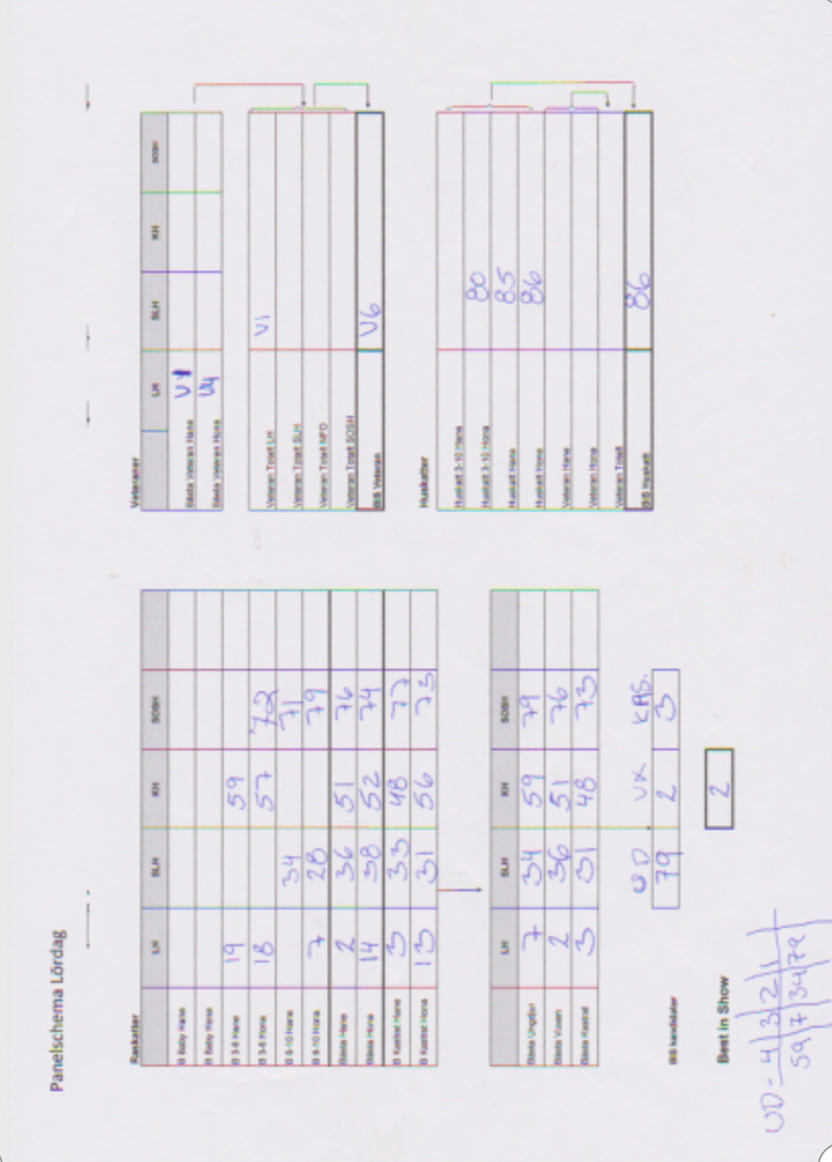

Beste katter søndag 14.06.2015 Rasekatter
 | Långhår | Semilånghår | Korthår | SOSH
Baby hann
Baby hunn
3-6 mnd hann |  |  | 59 Magic Box’Sapphire  SFS ay 25  Elena Busch, ORKK
3-6 mnd hunn | 18 Åkersborg HMAS Larrakia EXO n 22  Annette Thorèn Haage, BIK |  |  | 72 Lejonhjârtas Kitty Katt, OSH h 24  Fam Lundquist, FHK
6-10 mnd hann |  | 23 Rolf af Yum-Yum  BAL a  A.Fasting & V.Herland, SNRF |  | 71 Blueprint af Yum-Yum SH a 24  Bobo Göransson & Erica Sârnå, SNRF
6-10 mnd hunn | 7 Yàtos Saqhira  PER w 62  Ann-Louise & Clabbe Niesel, FHK | 28 DonTomas’s Unique  NFO w  Tomas Blom, SNRF | 47 Epiphany’s Eureka  BRI f 24  Annnika Ljung & Robin Larsson, FHK | 79 GoodWibes Maleficent  SYS f 01  Anna Andersdotter, FHK
Voksen hann | 2 S*Rönnbäret’s Black Zabath, PER n  Ann-Louise & Clabbe Niesel. FHK | 36 EC Miklagårds Gorm  NFO ns 09 22  Marina Jonsson, SNRF | 51 Metsäkansan Menninkäinen,BUR d  Tuuli Larva, KES-KIS | 76 Yum-Bo’s SnowStar  SIA w 67  G & B Hedberg, SNRF
Voksen hunn | 16 Crystal Pearl’s Angel of Love,PER fs  Gunnel Walther, FHK | 35 Mhorrses Chamosit  NFO ns 24  Marina Jonsson, SNRF | 41 S*Hot Stuff Larimar  BEN n 24  Anna & Ivar Wold, ORKK | 74 EC Lejonhjârtas Beautiful Barbie  SIA f  Fam Lundquist, FHK
Kastrat hann | 8A S*Chak-Mool’s Necesito  PER w 62  Britt-Marie Andersson, FHK | 33 Mhorrses Bruichladdich  NFO nt 24  Charlotte Erikanders, SNRF | 48 Zur Sternenbucht Pan Tau ,BRI ns 12  Kirsten Undset & Jarl Myhrene | 77 Yum-Bo’s SnowCrystal  SIA w 67  G & B Hedberg, SNRF
Kastrat hunn | 13 Åkantens Bonnie  PER f 22  Gunnel Walther, FHK | 31 EC & WP Mhorrses Seabreeze  NFO n 23  Marina Jonsson, SNRF | 45 IP S*Marsupilami’s Siv of Tigerlily BRI f  Marianne & Diana Sjöstrand, FHK | 73S*Nam Sook’s Lilly Rose,SIA e  Anna Andersdotter, FHK

 | Långhår | Semilånghår | Korthår | SOSH
Beste Ungdyr | 18 Åkersborg HMAS Larrakia,EXO n 22  Annette Thorèn Haage, BIK | 28 DonTomas’s Unique  NFO w  Tomas Blom, SNRF | 59 Magic Box’Sapphire  SFS ay 25  Elena Busch, ORKK | 79GoodWibes Maleficent, SYS f 01  Anna Andersdotter, FHK
Beste Voksen | 2 S*Rönnbäret’s Black Zabath,PER n  Ann-Louise & Clabbe Niesel. FHK | 36 EC Miklagårds Gorm  NFO ns 09 22  Marina Jonsson, SNRF | 51 Metsäkansan Menninkäinen  BUR d  Tuuli Larva, KES-KIS | 76Yum-Bo’s SnowStar  SIA w 67  G & B Hedberg, SNRF
Beste Kastrat | 13 Åkantens Bonnie  PER f 22  Gunnel Walther, FHK | 31 EC & WP Mhorrses Seabreeze  NFO n 23  Marina Jonsson, SNRF | 48 Zur Sternenbucht Pan Tau BRI ns 12  Kirsten Undset & Jarl Myhrene | 73 S*Nam Sook’s Lilly Rose SIA e  Anna Andersdotter, FHK

BIS  kandidater: | 79 GoodWibes Maleficent  SYS f 01  Anna Andersdotter, FHK | 2 S*Rönnbäret’s Black Zabath  PER n  Ann-Louise & Clabbe Niesel. FHK | 48 Zur Sternenbucht Pan Tau BRI ns 12  Kirsten Undset & Jarl Myhrene

BEST IN SHOW: | 79 GoodWibes Maleficent  SYS f 01  Anna Andersdotter, FHK

Veteraner

 | Långhår | Semilånghår | Korthår | SOSH
Beste  Veteran hann | V-1  Åsgreina’s Merkur  PER n 03  Arild Hoffsbakken, WEB
Beste Veteran  hunn | V-4  Salomez Lady Honey  PER fs  Gunnel Walther, FHK | V-6  EC & WP Mhorrses Seabreeze  NFO n 23  Marina Jonsson, SNRF

Veteran totalt LH | V-1  Åsgreina’s Merkur  PER n 03  Arild Hoffsbakken, WEB
Veteran totalt SLH | V-6  EC & WP Mhorrses Seabreeze  NFO n 23  Marina Jonsson, SNRF
Veteran totalt KH
Veteran totalt SOSH
BIS VETERAN | V-6  EC & WP Mhorrses Seabreeze  NFO n 23  Marina Jonsson, SNRF

Huskatter
Beste Huskatt 3-10 hann
Beste Huskatt 3-10 hunn | 80  Tuppen  HUS n 09  A.Fasting & V.Herland, SNRF
Beste Huskatt hann | 85  Bruce  HUS n  Thea Marie Livgard, ORKK
Beste huskatt hunn | 86  Zigrid  HUS n 09  Susanne Bodegart, FHK
BIS HUSKATT | 80  Tuppen  HUS n 09  A.Fasting & V.Herland, SNRF

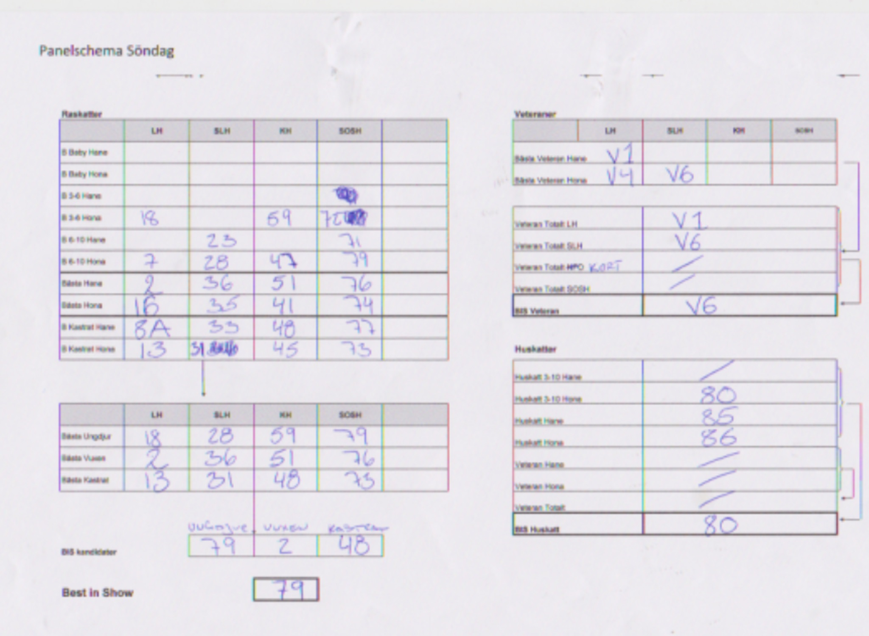

Ungdyrs RING 13/6.15 – 13 deltagare/participants

1 | 79 GoodWibes Maleficent | Hunn | Anna Anderdotter, FHK
2 | 34 DonTomaso’s Tiger | Hann | Tommy Blom, Sverak
3 | 25 NO* Antelis Nike Stortass | Hunn | Sara Mathea Mikkelsen, Østfoldkatten
4 | 18 Åkersborgs HMAS Larrakia | Hunn | Annette Thorèn Haage, BIK
5 | 26 NO*Actress Black Widow | Hunn | Connie Skeie, NRR
6 | 30 DonTomasos’s Troya | Hunn | Tommy Blom, Sverak
7 | 78 Roger af Yum-Yum | Hann | A.Fasting & V.Herland, SNRF

Voksen RING 13/6.15 – 17 deltagare/participants

1 | 2 S*Rönnbäret’s Black Zabath | Hann | Ann-Louise & Clabbe Niesel, FHK
2 | 21 Åkersborg’s Colour Fur You | Hunn | Annika Ljung & Robin Larsson, FHK
3 | 67 SE*Qjou’s Ce La Vie | Hann | Wibekke Berge, ORKK
4 | 50 DK*Empire’s Venus de Milo | Hunn | Annette Thorèn Haage, BIK
5 | 20 Flora Mortishia*PL | HUNN | Heidi Johanne Bråten, ORKK
6 | 52 CH NO*Lindormens Kilah McKensy | Hunn | Ann-Chathrine & Terje Storli, Østfoldkatten
7 | 14 Åkantens Love Affair | Hunn | Britt-Marie Andersson, FHK
8 | 43 LizPaws Abeba Aregawi | Hunn | Elisabeth & Roy Fridlund, KKN
9 | 39 Sabertooth Bella Rosa | Hunn | Elena Busch & Odd Møglestue, ORKK

Kastrat RING 13/6.15 – 12 deltagare/participants
1 | 3 W 12 Åkantens Nicki Pedersen | Hann | Britt-Marie Andersson, FHK
2 | 48 Zur Sternerbucht Pan Tau | Hann | Kirsten Undset & Jarl Myhrene, ORKK
3 | 73 CH NamSooks Lilly Rose | Hunn | Anna Andersdotter, FHK
4 | 32 Mhorrses Kalahari | Hann | Charlotte Erikanders, SNRF
5 | 31 EC & WP Mhorrses Seabreeze | Hunn | Marina Jonsson, SNRF
6 | 17 Salomes Lady Honey | Hunn | Gunnel Walther, FHK

Huskatt RING 13/6.15 – 6 deltagare/participants
1 | 86 Zigrid |  | Hunn | Sussane Bodegart, FHK
2 | 84 Qumo’s Sidney |  | Hunn | Joakim Hagberg, ORKK
3 | 85 Bruce |  | Hann | The M Livgard, ORKK

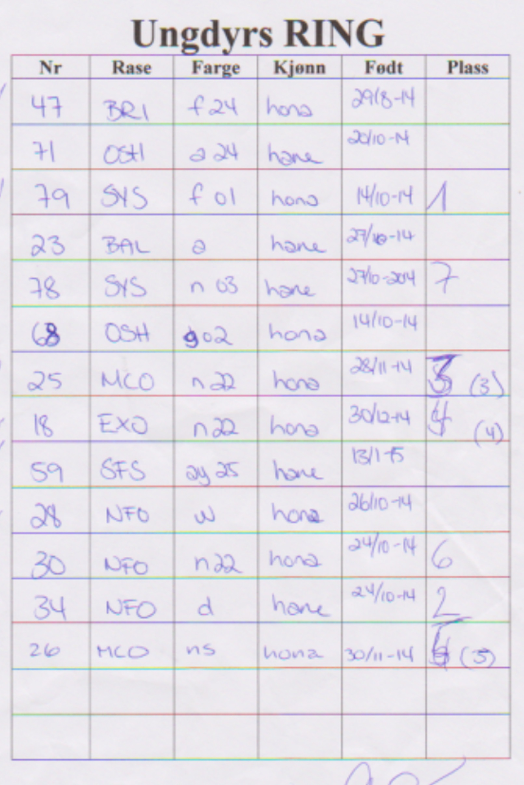

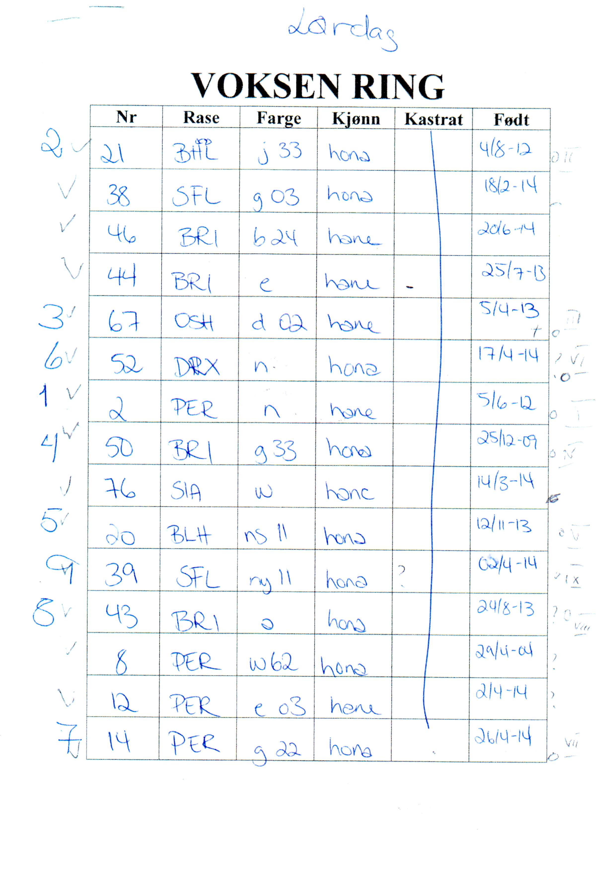

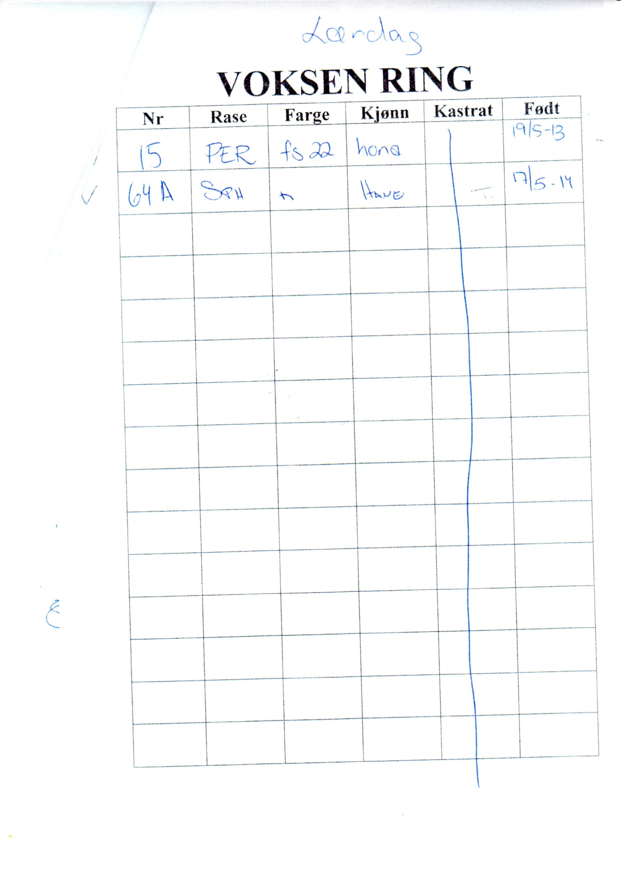

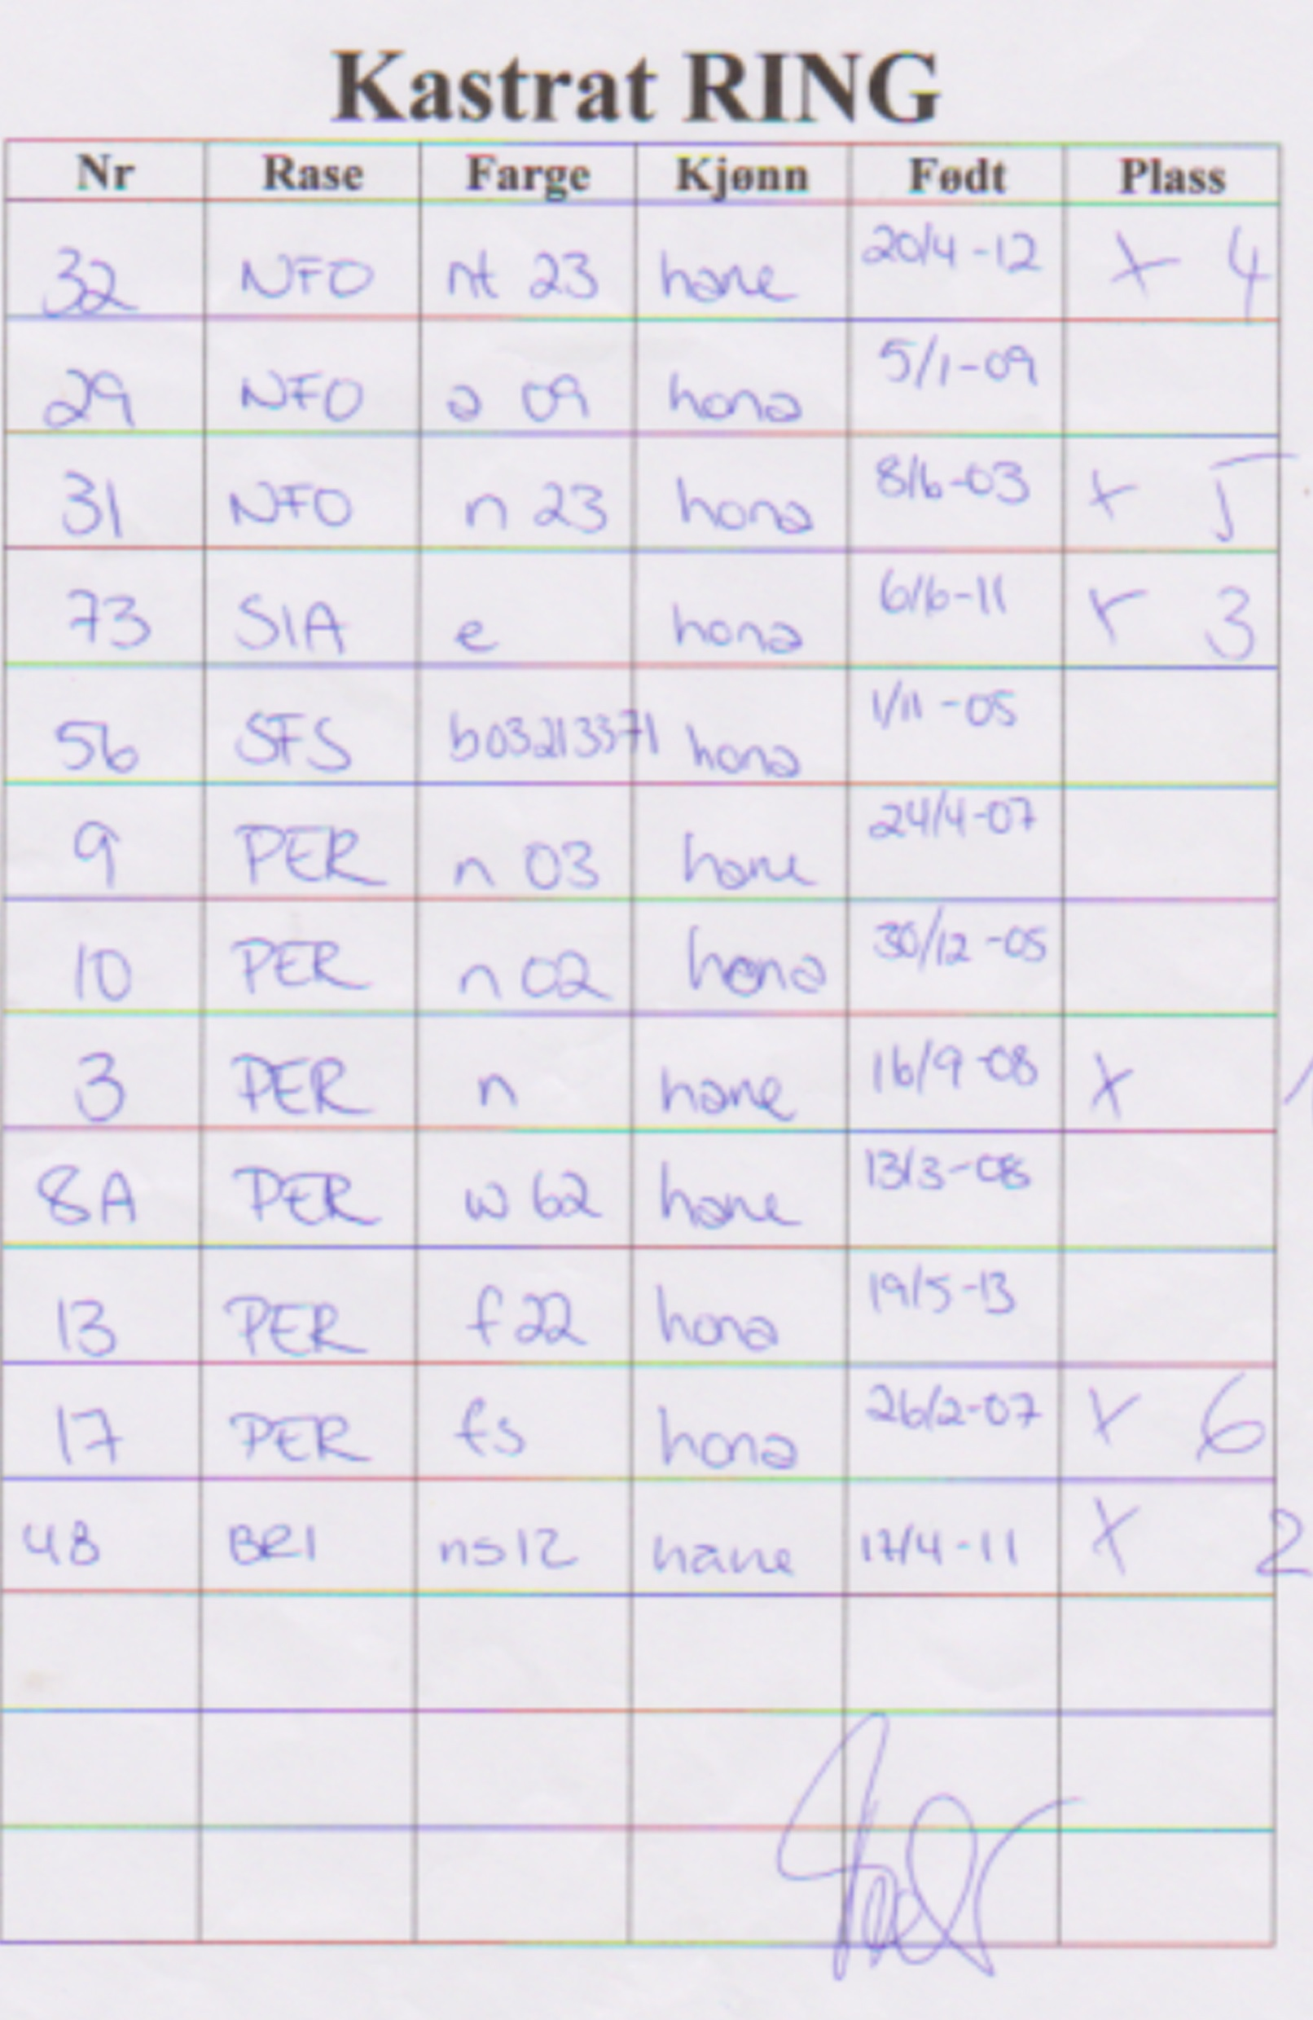
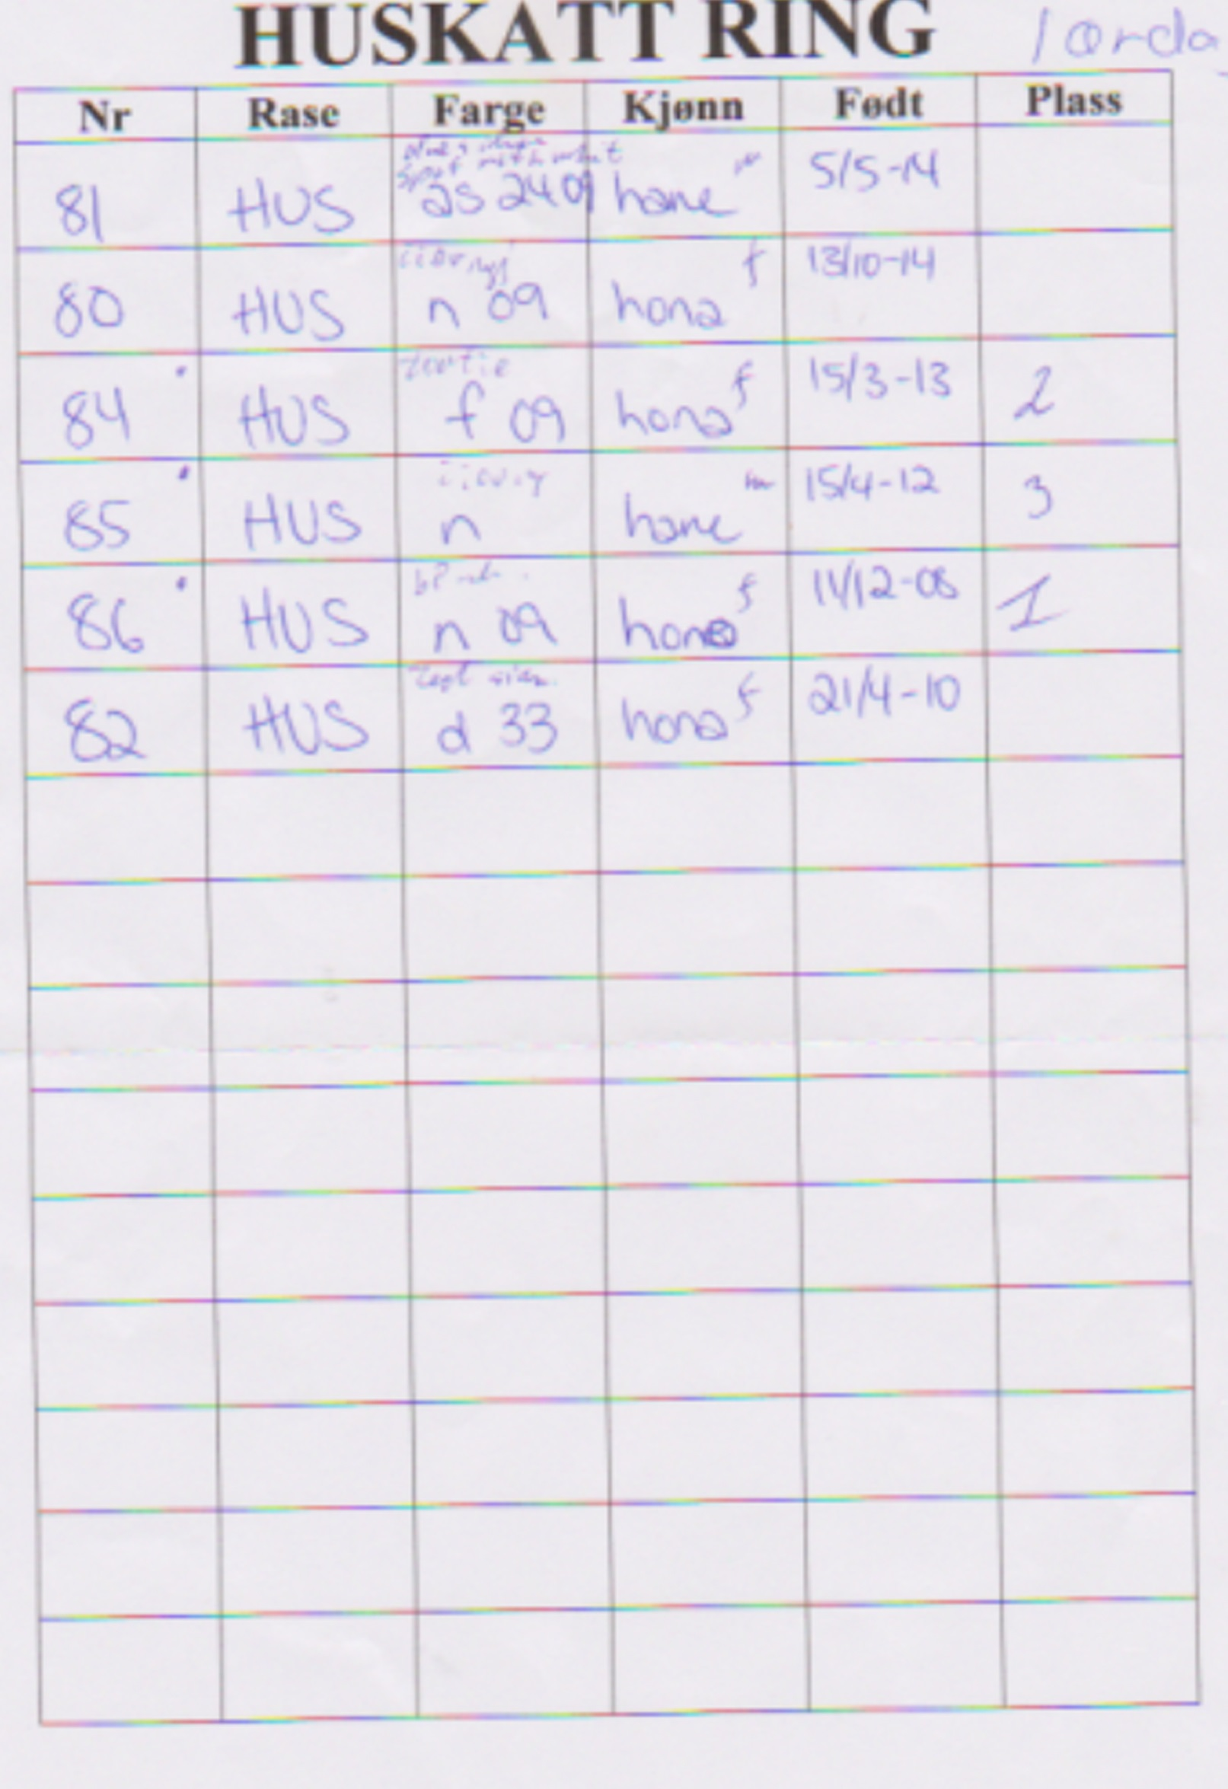

Ungdyrs RING 14/6.15 – 10 deltagare/participants

1 | 68 GoodWibes Saphira | Hunn | Wibekke Berge, ORKK
2 | 59 Magic Box’s Sapphire | Hann | Elena Busch, ORKK
3 | 18 Åkersborgs HMAS Larrakia | Hunn | Annette Thorèn Haage, BIK
4 | 26 NO*Actress Black Widow | Hunn | Connie Skeie, NRR
5 | 23 Rolf af Yum-Yum | Hann | A.Fasting & V.Herland, SNRF

Voksen RING 14/6.15 – 11 deltagare/participants

1 | 76 Yum-Bo’s SnowStar | Hann | Gunnel och Bo Hedberg, SNRF
2 | 2 S*Rönnbäret’s Black Zabath | Hann | Ann-Louise & Clabbe Niesel, FHK
3 | 51 Metsäkansan Menninkäinen | Hann | Tuuli Larva, KES-KIS
4 | 43 LizPaws Abeba Aregawi | Hunn | Elisabeth & Roy Fridlund, KKN
5 | 39 Sabertooth Bella Rosa | Hunn | Elena Busch & Odd Mæglestue, ORKK
6 | 53Aradia av Blue Ocean | Hunn | Gabrielle Aarnæs & Anja Pedersen, ORKK

Kastrat RING 14/6.15 – 6 deltagare/participants

1 | 48 Zur Sternerbucht Pan Tau | Hann | Kirsten Undset & Jarl Myhrene, ORKK
2 | 3 NW 12Åkantens Nicki Pedersen | Hann | Britt-Marie Andersson, FHK
3 | 32 Mhorrses kalahari | Hann | Charlotte Erikanders, SNRF

Huskatt RING 14/6.15 – 6 deltagare/participants

1 | 81 Ozzy | Hann | Charlotte Erikanders, SNRF
2 | 80 Tuppen | Hunn | A.Fasting & V.Herland, SNRF
3 | 83 Tiger | Hann | Anita Salo, KKN

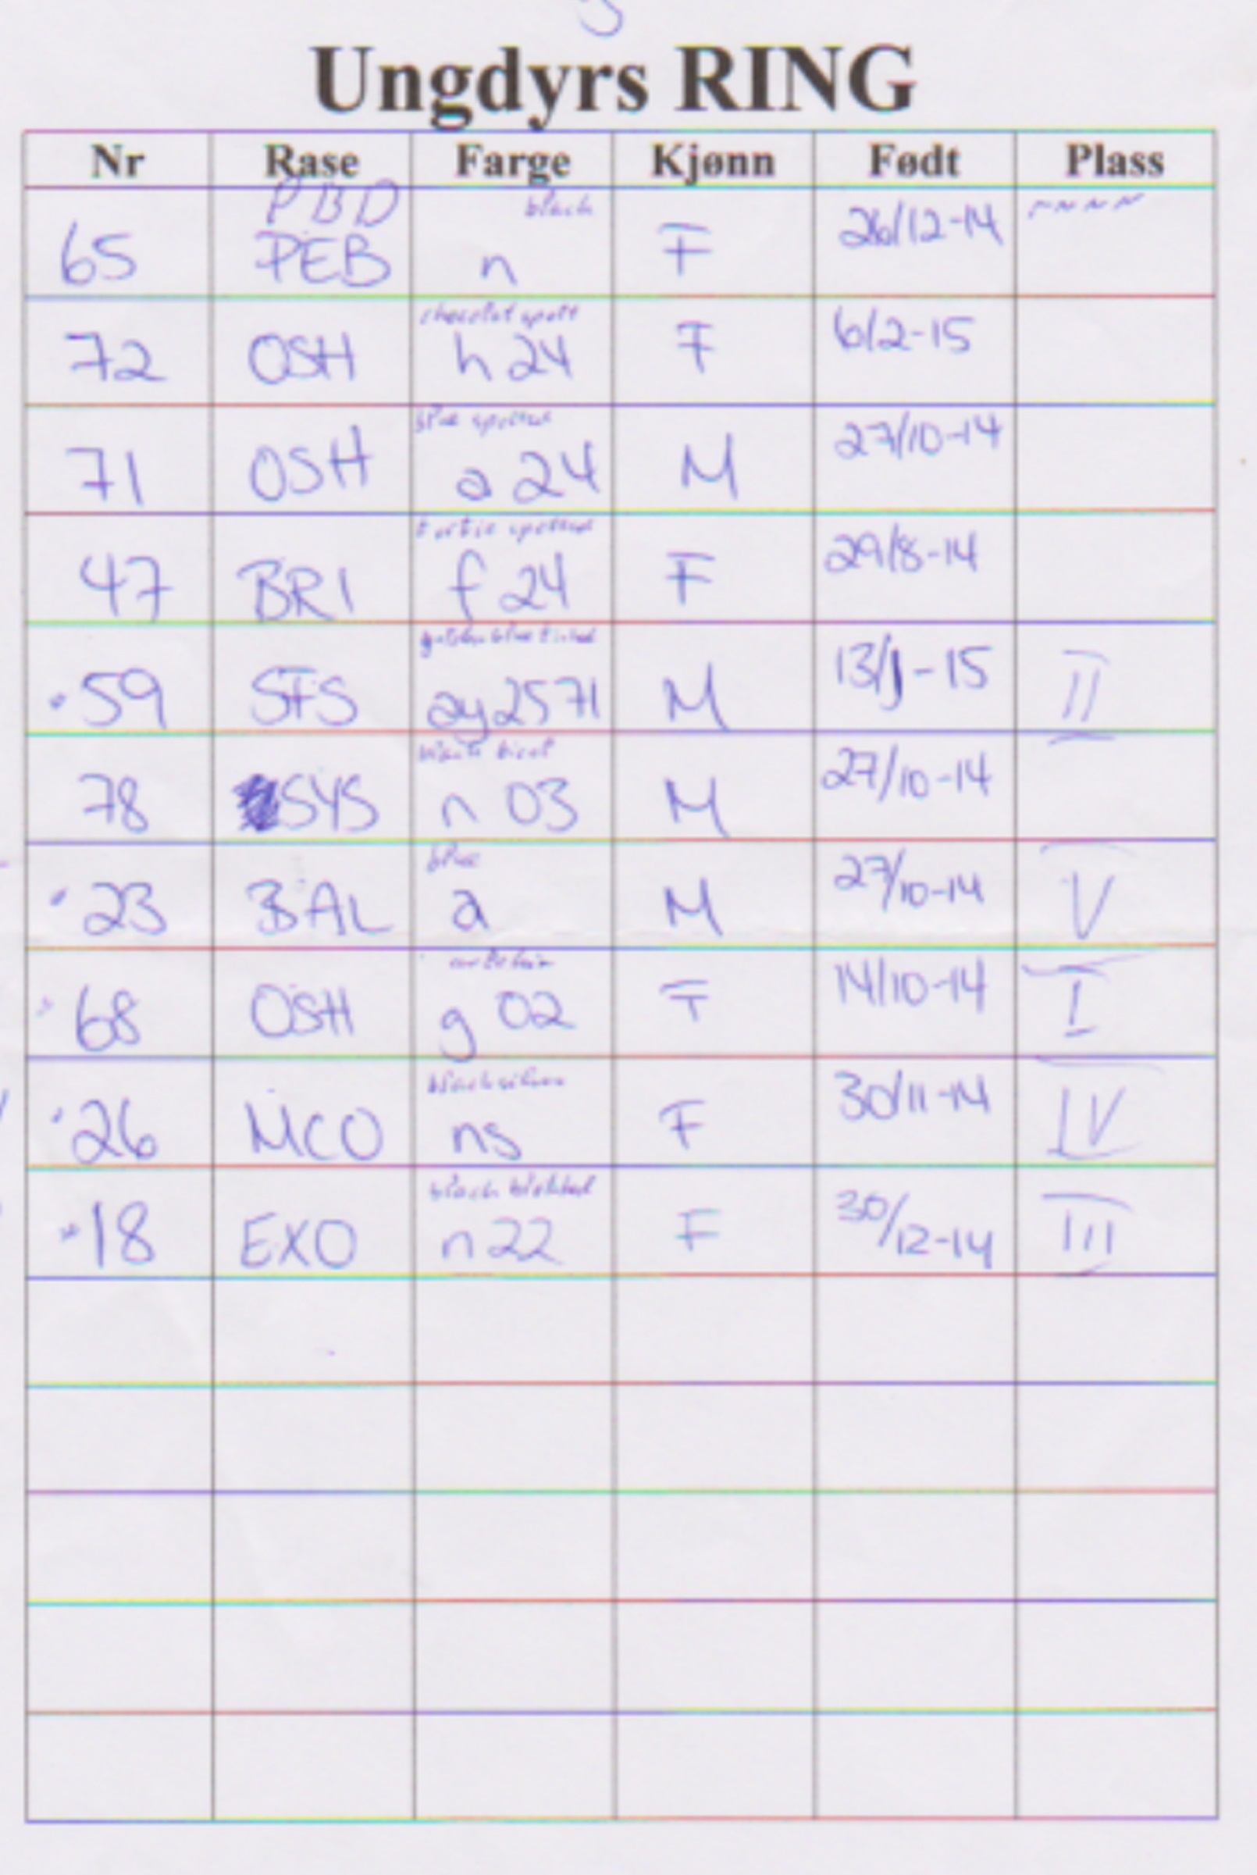

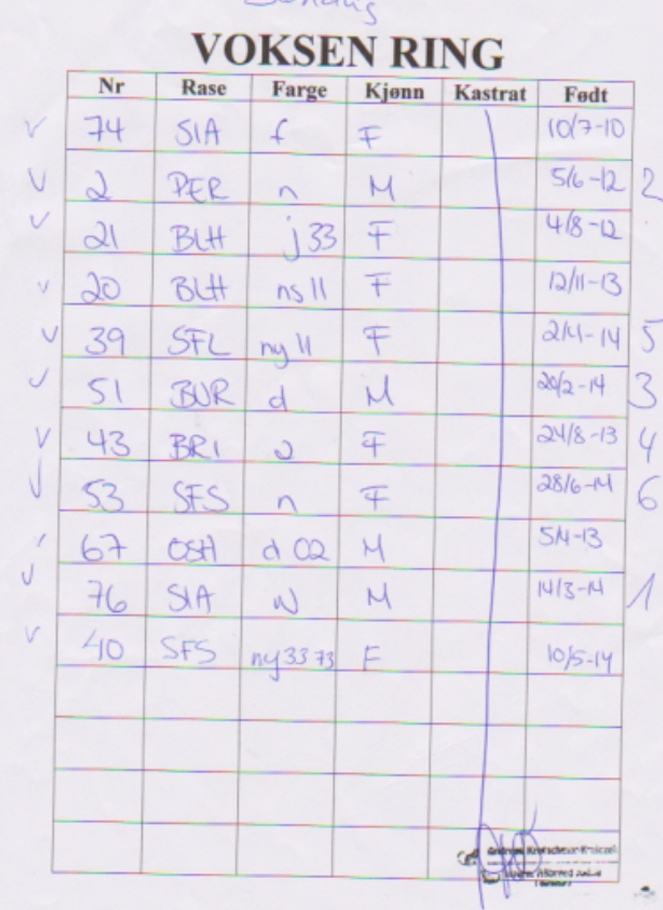
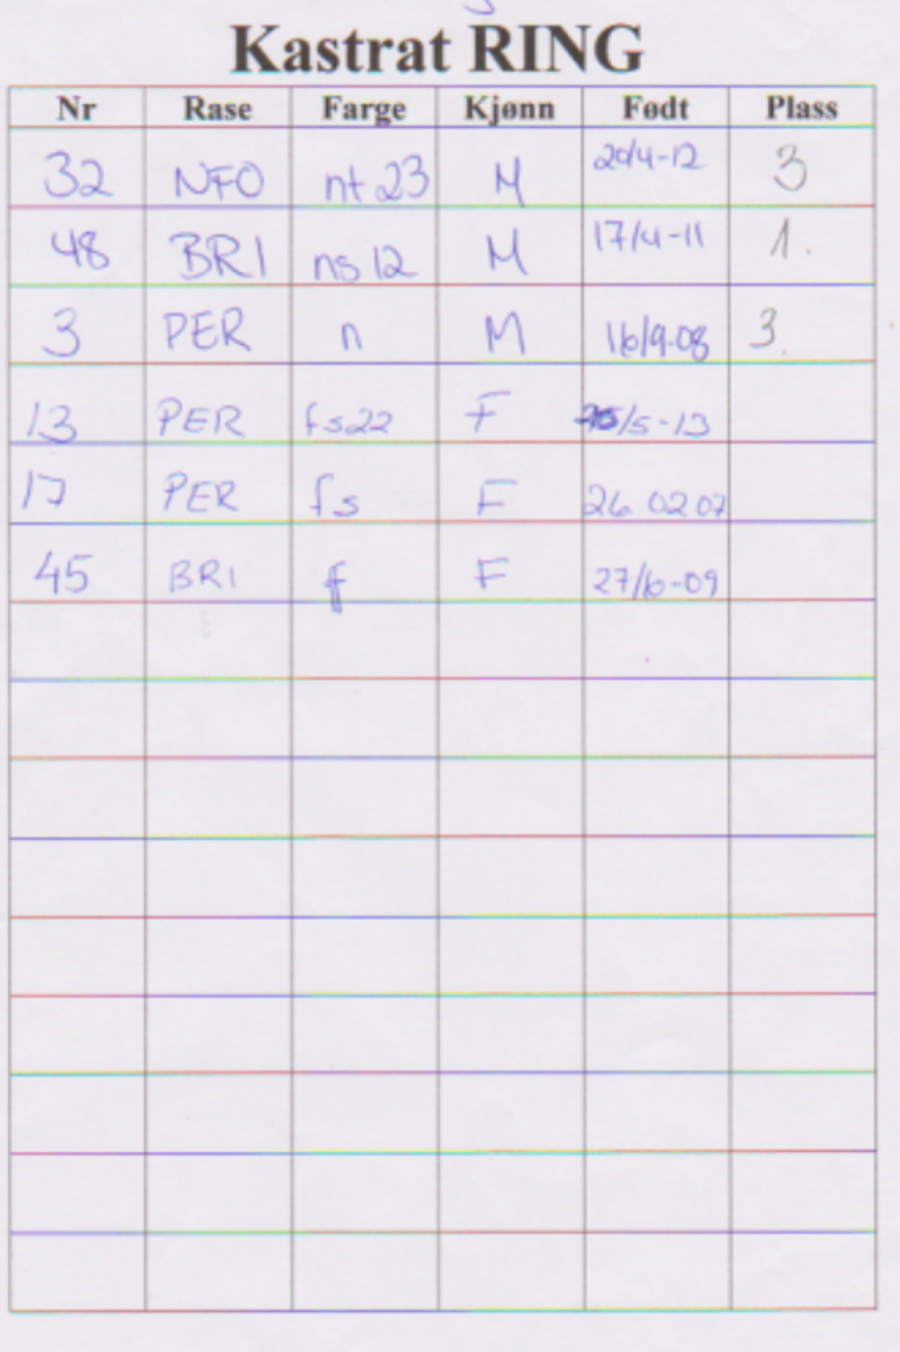

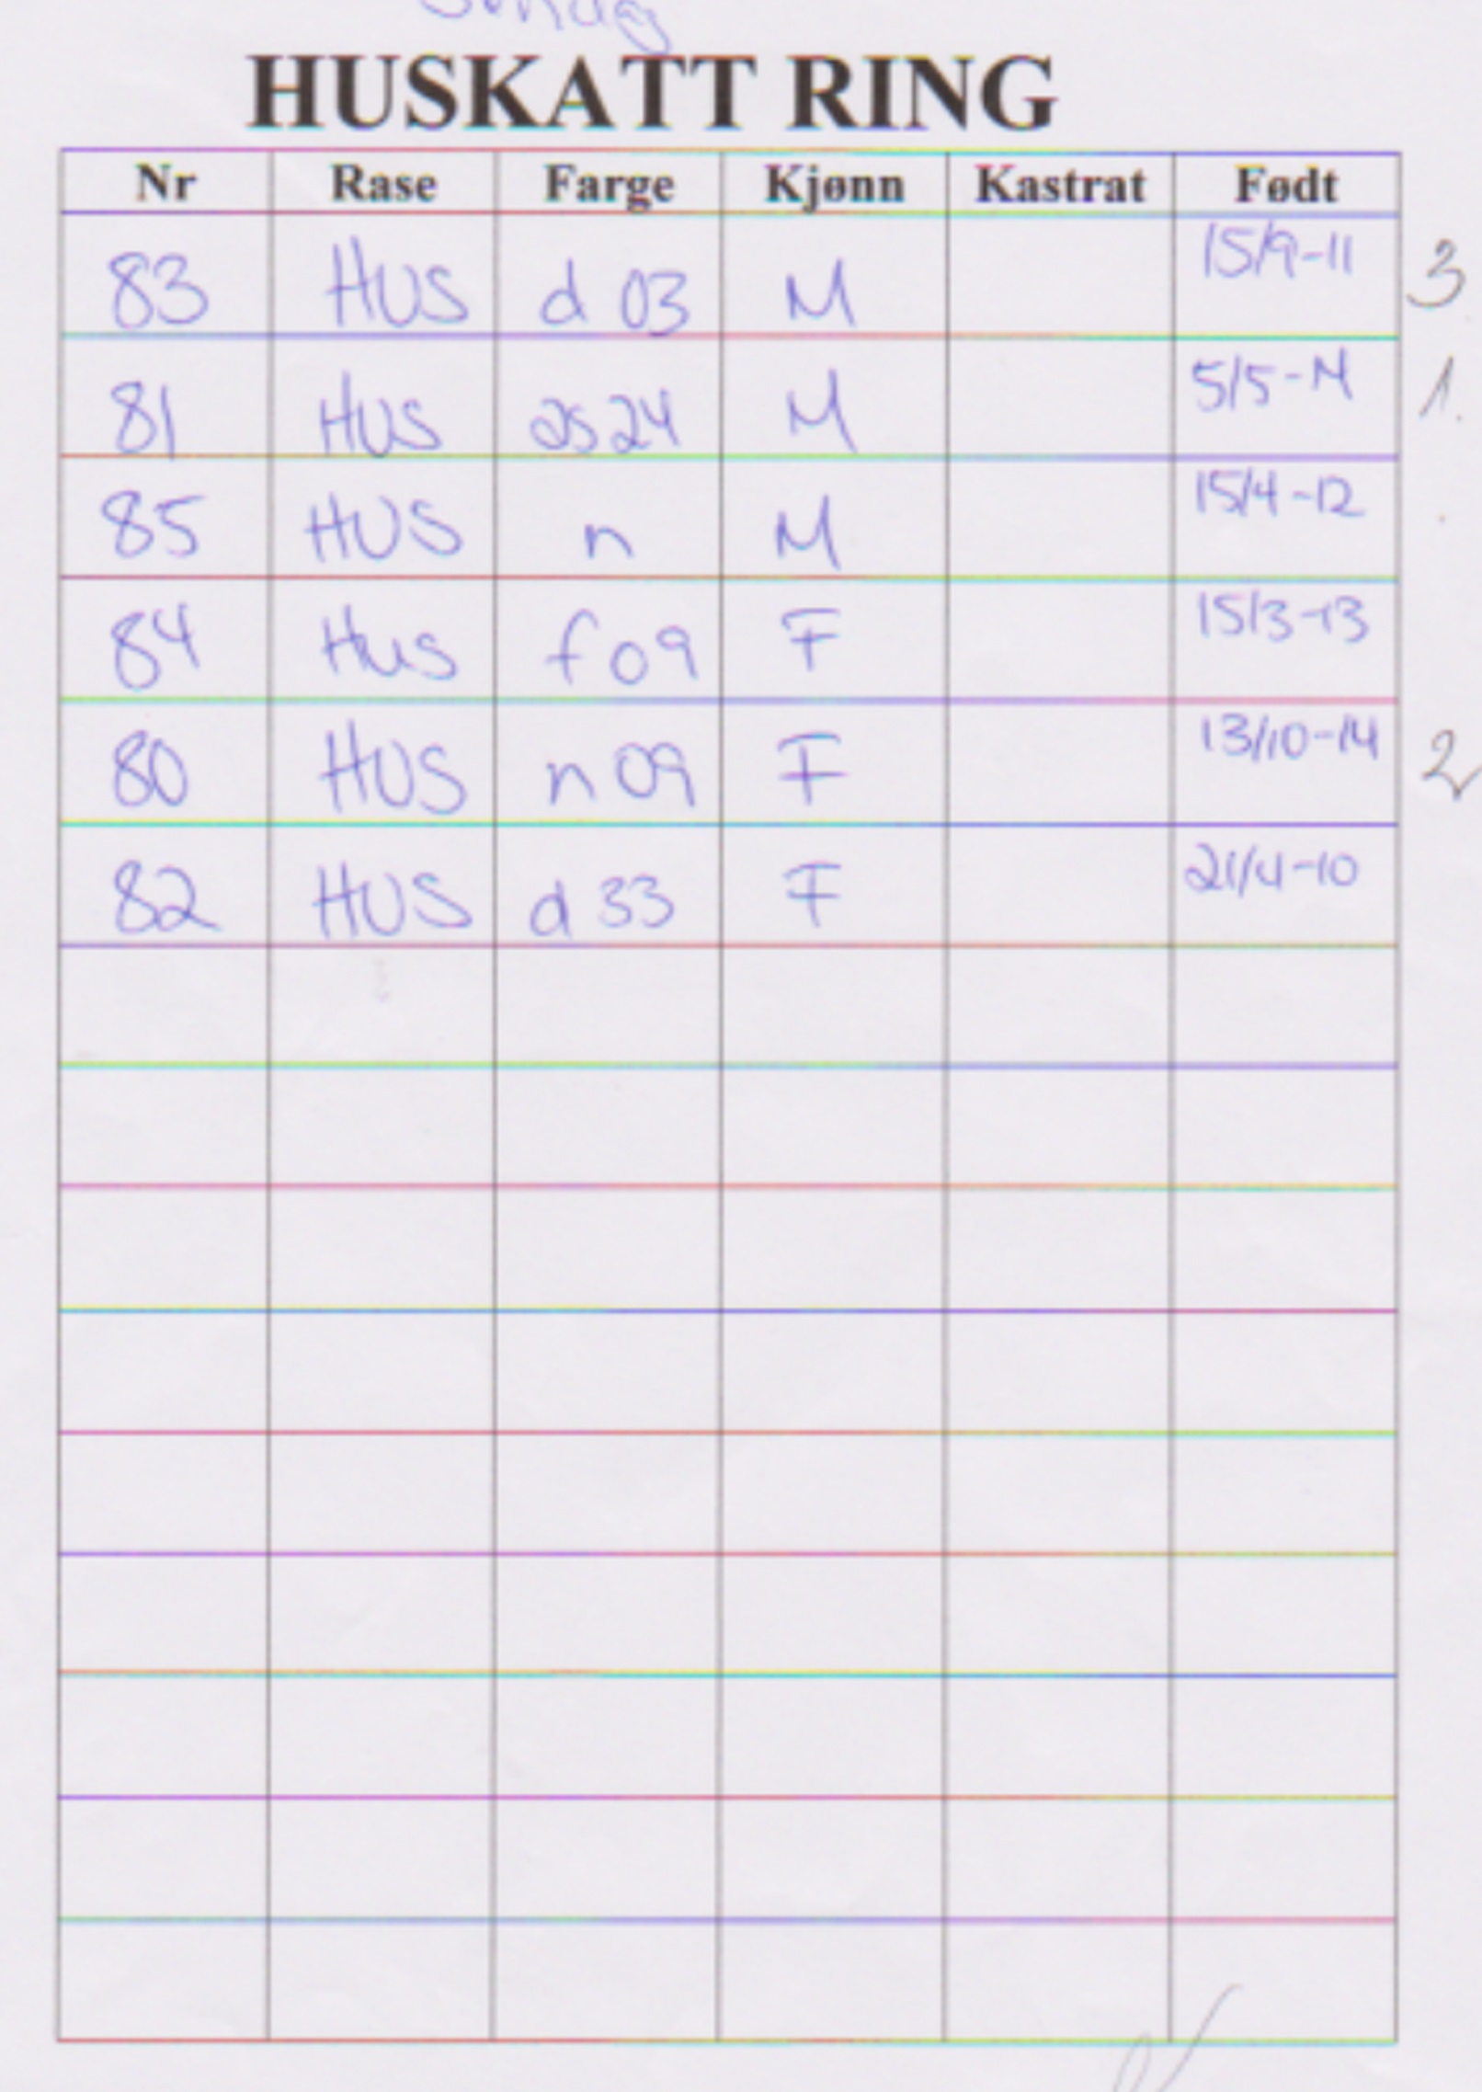

EXOTIC

Tabby

Klasse 16 hunn
18 Åkersborgs HMAS Larrakia
F: 30.12.2014
F: CH Chusingura’s Hazard
M: IDP*Crystal Pearl’s Nannsy
O/E: Annette Thorèn Haage, BIK
Lør: EX 1, DB
Søn: EX 1, DB

PERSER

Solid

Svart

Klasse 11 hunn
1 Åkantens Milliflori
F: 11..07.2011
F: NW 12 Åkantens Nicki Pedersen
M: Åkantens Kissed by the Chamelon
O/E: Britt-Marie Andersson, FHK
Lør: CACIB
Søn: CACIB

Klasse 7 hann
2 S*Rönnbäret’s Black Zabath
F: 05.06.2012
F: CH DK*Perli-Gems’ Ebony Light
M: CH S*Scarlet’s Rosanna
O: Rut Sloberg
E: Ann-Louise & Clabbe Niesel, FHK
Lør: Grand Int Champ, BIV BIG BIR, DB
Søn: CACE, BIV, BIG, BIR, DB

Klasse 8 hann
3 NW 12 Åkantens Nicki Pedersen
F: 16.09.2008
F: S*IxiDixi’s Moonshine
M: S*Eddore O’Susannah
O/E Britt-Marie Andersson, FHK
Lør: Premier of Europe, DB
Søn: GCAPE

Blå
Klasse 13 hann
4 Åkanten’s Moon Light
F: 26.04.2014
F: IC Boggie’s Pop Music
M: Åkanten’s Millifiori
O: Britt-Marie Andersson
E: Mari-Ann Andersson, FHK
Lør: CAC
Søn: Champion

Svartskilpadde

Klasse 8 hunn
5 AnnHalle’s Lucia Viktoria
F: 24.05.2009
F: EC S*Kappes Prince of Salomez
M: Åkantens Creme de la Creme Molly Mahal
O/E Mari-Ann Andersson, FHK
Lør: CAPE
Søn: CAPE

Blåskilpadde

Klasse 11 hunn
6 S*Rönnbäret’s Lilla Cup Cake¨s
F: 30.06.2013
F: CH DK*Perli-Gams¨Ebony Light
M: CH S*Scarlet’s Rosanna
O: Rut Sloberg
E: Ann-Louise & Clabbe Niesel, FHK
Lør: Int Champion
Søn: CAGCIB, DB

Klasse 15 hunn
7 Yàtos Saqhira
F: 13.08.2014
F: S*Rönnbärets Black Zabath
M: S*Rönnbärets Zöta Zofia
O/E: Ann-Louise & Clabbe niesel, FHK
Lør: EX 1, DB,
Søn: EX 1, DB

Klasse 3 hunn
8 Åsgreina’s You are Our Dream
F: 29.04.2004
F: EC/WP JeMitziz Enter My World
M: EC/EP Cobra av Baune JW NW `T07
O/E: Anne Hoffsbakken, ORKK
Lør: CACM
Søn: CACM

Klasse 8 hann
8A S’Chak-Mool’s Necesito
F: 13.03.2008
F: EC (N) DuMonet Christian Dior
M: CH (N)Uno White Princess of Chak-Mool’s
O: Helena Hansson
E: Britt-Marie Andersson, FHK
Lør: CAPE, BIV
Søn: CAPE, BIV, DB

Bicolour

Svart/hvit

Klasse 4 hann
9 Åsgreina’s Merkur
F: 24.04.2007
F: CH S*Meibel’s Dàrtagnan
M: GC/ IP Åsgreina’s Månestråle
O: Anne Hoffsbakken
E: Arild Hoffsbakken, WEB
Lør: CAPM, DB
Søn: CAPM, DB

Svart/hvit HQ

Klasse 10 hunn
10 Åsgreina’s Månestråle
F. 30.12.2005
F: EC/WP JeMitziz Enter My World
M: EC/EP Cobra av Baune JW NW `T07
O: Anne Hoffsbakken
E: Anne Hoffsbaken, ORKK
Lør: CAGPIB
Søn: Grand Int Premier

Rød/hvit

Klasse 13 hann
11
UTGÅR

Krem/hvit

Klasse 13 hann
12 S*Freeloader’s Snoopi
F: 02.04.2014
F: S*Headturners Dressed In Black
M: S*Kissleberg’s Sanne
O: Maria Fredholm
E: Arild Hoffsbakken, WEB
Lør: Champion, BIG, DB
Søn: CACIB, BIG, DB

Tabby

Svartskilpaddetabby

Klasse 12 hunn
13 Åkantens Bonnie
F: 19.05.2013
F: CH Boggie’s Pop Music
M: Åkantens Kissed By The Chameleon
O: Britt-Marie Andersson
E: Gunnel Walther, FHK
Lør: CAPIB, BIG, DB
Søn: CAPIB, BIG, DB

Blåskilpaddetabby

Klasse 13 hunn
14 Åkantens Love Affair
F: 26.04.2014
F: IC S*Boggie’s Pop Music
M: Åkantens Milliflori
O/ E: Britt-Marie Andersson, FHK
Lør: Champion, DB
Søn: CACIB

14 A Boggie’s Pop Music
F: 09.05.2012
F: S*Ambraz Swede L Hamilton
M: S’IxiDixi’s Ghost Whisperer JW
O: Kicki Thenberg
E: Britt-Marie Andersson, FHK
Lør: ABS
Søn: ABS

Svartskilpadde silvertabby

Klasse 11 hunn
15 Åkantens Filippa
F: 19.05.2013
F: CH Boggie’s Pop Music
M: Åkantens Kissed By The Chameleon
O: Britt-Marie Andersson
E: Gunnel Walther, FHK
Lør: CACIB
Søn: CACIB

Silver

Svartskilpaddesmoke

Klasse 9 hunn
16 Crystal Pearl’s Angel of Love
F: 08.04.2012
F: WCh Hassellidens Tabby Pepelino
M: Crystal Pearl’s Smoke Alicia
O: Marita Lind
E: Gunnel Walther, FHK
Lør: Int Champion, DB
Søn: CACE, DB

Svartskilpadde smoke

Klasse 10 hunn
17 Salomes Lady Honey
F: 26.02.2007
F: EC*Kappes Prins of Salomez
M: Yazz Selene
O/E Gunnel Walther, FHK
Lør: Grand Int Premier, DB
Søn: CAPE, DB

BRITTISK LANGHÅR

Tabby

Blå golden ticked

Klasse 16 hann
19 Ducky Honey Holiday
F: 07.01.2015
F: Velvet Honey Holyday
M: Helli Precious Plush Dream
O: Marina Botasheva
E: Ramiza Musa Syed & Linda Jensen, ORKK
LørEX 1, BIR, DB
Søn: ABS

Sølv

Svart silver shaded

Klasse 13 hunn
20 Flora Mortishia*PL
F: 12.11.2013
F: Egon of Moon Sissi*CE
M: CH Yævira Joanna
O: Justyna Kuling
E: Heidi Johanne Bråten, ORKK
Lør: CAC
Søn: CAC
TIL AVL

Colourpoint

Lillaskilpaddemasket

Klasse 7 hunn
21 Åkersborg’s Colour Fur You
F: 04.08.2012
F: IC*Brilliant’s Wesselton
M: CH DK*Empire’s Venus de Milo
O: Annette Thor\en Haage
E: Annika Ljung & Robin Larsson, FHK
Lør: CACE
Søn: CACE

Blåsilver shaded masket

Klasse 15 hunn
22 Princess Patricia Adamas Magicus
F: 16.11.2014
F: WCH Russo Norton
M: Lemurcat Niferkikki
O: Adamas Magicus
E: Ramiza Musa Syed, ORKK
LørEX 1, DB
Søn: ABS

VETERAN LÅNGHÅR

Klasse 21 hann
V–1 PERSER svart/hvit bicolour
Åsgreina’s Merkur
F: 24.04.2007
F: CH S*Meibel’s Dàrtagnan
M: GC/ IP Åsgreina’s Månestråle
O: Anne Hoffsbakken
E: Arild Hoffsbakken, WEB
Lør: EX 1, DB
Søn: EX 1, DB

Klasse 21 hunn
V–2 PERSER Hvit orangeøyd
Åsgreina’s You are Our Dream
F: 29.04.2004
F: EC/WP JeMitziz Enter My World
M: EC/EP Cobra av Baune JW NW `T07
O/E: Anne Hoffsbakken, ORKK
Lør: EX 2
Søn: EX 3

V-3 PERSER Svart/Hvit HQ
Åsgreina’s Månestråle
F. 30.12.2005
F: EC/WP JeMitziz Enter My World
M: EC/EP Cobra av Baune JW NW `T07
O: Anne Hoffsbakken
E: Anne Hoffsbaken, ORKK
Lør: EX 3
Søn: EX 2

V-4 PERSER Svartskilpadde smoke
Salomes Lady Honey
F: 26.02.2007
F: EC*Kappes Prins of Salomez
M: Yazz Selene
O/E Gunnel Walther, FHK
Lør: EX 1, DB
Søn: EX 1, DB

BALINES

Colourpoint

Blåmasked

Klasse 15 hann
23 Rolf af Yum-Yum
F: 27.10.2014
F: Prince George af Yum-Yum
M: Raske Romona af Yum-Yum
O/E: Anneke Fasting & Viktor Herland, SNRF
Lør: EX 1
Søn: EX 1, DB

HELLIG BIRMA

Colourpoint

Blåskilpaddetabby masket

Klasse 14 hunn
24 S*KällaLycka’s Valencia
F: 10.04.2005
F: S*KällaLycka’s Laurence LillRöd
M: S*KällaLycka’s Hjördis
O: Birgit Johansson & Elna Käll
E: Maria Pettersson, BIK
Lør: ABS
Søn: ABS

MAINE COON

Agouti

Bruntabby

Klasse 15 hunn
25 NO*Antelis Nike Stortass
F: 28.11.2014
F: S*Stoltassens Dagobert
M: CH S*Stortassens Yulie
O: Line Edvartsen
E: Sara Mathea Mikkelsen, Østfolkatten
Lør; EX 1, DB

Nonagouti

Svartsmoke

Klasse 15 hunn
26 NO*Actress Black Widow
F: 30.11.2014
F: (N)Mountain cat’s Jax
M: NO*Adnruszaks Exciting Destiny
O/E: Connie Skeie, NRR
Lør: EX 1
Søn: EX 1

NORSK SKOGKATT

Nonagouti

Svart

Klasse 7 hann
27 DonTomaso’s Nemo
F: 12.04.2011
F: EC Källbokattens Harald
M: WCH S*Vimmerskogens Amorina
O: Tomas Blom
E: Tomas Blom, SNRF
Lør: CACE
Søn: Champ of Europe

Hvit

Klasse 15 hunn
28 DonTomaso’s Unique
F: 26.10.2014
F: S*Ängsnejilans Picasa
M: DonTomas’s Ice Queen
O: Tomas Blom
E. Tomas Blom, SNRF
Lør: EX 1, DB
Søn: EX 1, BIG, BIR, DB

Nongouti/hvit

Blå/hvit

Klasse 12 hunn
29 S*Annihodds Yama Ywett
F: 05.01.2009
F: Nelson
M: S*Anniehoods Poochena
O: Marina Pettersson
E: Anita Salo, KKN
Lør: CAPIB
Søn: CAPIB

Agouti

Bruntabby

Klasse 16 hunn
30 DonTomaso’s Troya
F: 24.10.2014
F: DonTomaso’s Nemo
M: S*NC’s Prima Donna
O: Tomas Blom
E: Tommy Blom, SVERAK
Lør: EX 1 BIR, DB
Søn: EX 1, DB

Svarttigrè

Klasse 2 hunn
31 EC &WP Mhorrses Seabreeze
F: 08.06.2003
F: S*Alfskogen’s George Harrisson
M: Ch Mhorrses Daiquiri
O: Marina Jonsson
E: Marina Jonsson, SNRF
Lør: HP BIG, DB
Søn: HP 1 BIG, DB

Ambertigre

Klasse 8 hann
32 Mhorrses Kalahari
F: 21.04.2012
F: IC S*Wildwood’s Fezter
M: Mhorrses Wembley
O: Marina Jonsson
E: Charlotte Erikanders, SNRF
Lør: Premier of Eurpoe
Søn: GCAPE

Amberspotted

Klasse 4 hann
33 Mhorrses Bruichladdich
F: 11.02.2011
F: IC S*Wildwood’s Fetzer
M: Mhorrses Wembley
O: Marina Jonsson
E: Chralotte Erikanders, SNRF
Lør: CAPM, DB
Søn: CAPM, DB

Rødtabby

Klasse 15 hann
34 DonTomaso’s Tiger
F: 24.10.2014
F: DonTomasos’s Nemo
M: S*NC’Prima Donna
O: Tomas Blom
E: Tommy Blom, Sverak
Lør: EX 1 BIG, DB
Søn: EX 1

Svartsilverspotted
Klasse 11 hunn
35 Mhorrses Chamosit
F: 29.10.2013
F: EC Miklagårds Gorm
M: GIC Mhorrses Alyona
O/E: Marina Jonsson, SNRF
Lør: CACIB
Søn: CACIB, DB

NORSK SKOGKATT

Agouti/hvit

Svartsilvertabby/hvit
Klasse 3 hann
36 Miklagårds Gorm
F: 22.11.2011
F: GIC S*Runsvik’s Quasimodo
M: GIC Miklagårds Bestla
O: Karin Schlyter
E: Marina Jonsson, SNRF
Lør: Gr Cham of Europe, BIG, DB
Søn: CACM, DB

ORIENTALSK LANGHÅR

Sjokoladespotted

Klasse12 hunn
37 DK*Arjuna’s Hurricane
F: 06.07.2007
F: Swe-Scot Quincy
M: DK*Arjuna’s Morgan Le Fay
O: Anne Korsbakke
E: Annekke Fasting & Viktor Herland, SNRF
Lør: Int Champ, DB
Søn: CAGPIB, DB

SCOTTISH FOLD LANGHÅR

Hvitflekk

Klasse 13 hunn
38 Barbara Limpopo
F: 18.02.2014
F: TigerSun Simbo
M: Flipper Hoya
O: Elena Shapovalova
E: Monica Kristensveen, SNRF
Lør: Champion, BIR, DB
Søn: CACIB

Golden

Klasse 13 hunn
39 Sabertooth Bella Rosa
F: 02.04.2014
F: Glamour Golden Perfection
M: Ice Queen vom Zarentiger
O: Linda Jensen
E: Elena Busch & Odd Møglestue, ORKK
Lør: Champion
Søn: CACIB, BIR, DB

Colourpoint

Shaded goldenmasked

Klasse 13 hunn
40 Rami’s Adorabelle
F: 10.05.2014
F: Glamour Golden Perfection
M: goodwill House Zena Grey
O: Ramisa Syed
E: Annette Thorèn Haage, FHK

VETERAN SEMI

Klasse 21 hunn
V-5 HELLIG BIRMA Blåskilpadde tabby masket
S*KällaLycka’s Valencia
F: 10.04.2005
F: S*KällaLycka’s Laurence LillRöd
M: S*KällaLycka’s Hjördis
O: Birgit Johansson & Elna Käll
E: Maria Pettersson, BIK
Lør: ABS
Søn: ABS

V-6 NFO Svarttigre
EC &WP Mhorrses Seabreeze
F: 08.06.2003
F: S*Alfskogen’s George Harrisson
M: Ch Mhorrses Daiquiri
O: Marina Jonsson
E: Marina Jonsson, SNRF
Lør: EX 1, DB
Søn: EX 1, DB

V-7 ORIETALSK LANGHÅR
Sjokoladespotted
DK*Arjuan’a Hurricane
F: 06.07.2007
F: Awe-Scot Quincy
M: DK*Arjuna’s Morgan Le Fay
O: Anne Korsbakke
E: Annekke Fasting & Viktor Herland, SNRF
Lør: EX 2
Søn: EX 2

BENGAL

Brunspotted

Klasse 13 hunn
41 S*Hot Stuff Larimar
F: 29.09.2014
F: Murenacat Pax Orion
M: Gyfi’s Frøya
O: Maria Andersson
E: Anna & Ivar Wold, ORKK
Lør: EX 2
Søn: CAC, DB

42 Arcticbengals Lulu
F: 21.10.2013
F: Canpour Cloud Formation
M: Arcticbengals Brown Snow
O: Tove Ingrid & Per Lausund
E: Anna & Ivar Wold, ORKK
Lør: CAC, DB
Søn: EX 2

BRITTISK KORTHÅR

Solid

Blå

Klasse 13 hunn
43 LizPaws Abeba Aregawi
F: 24.08.2013
F: Quicksilver Colourist
M: Smuggler Rhythm and Blues
O/E: Elisabeth & Roy Fridlund, KKN
LørChamp
Søn: CACIB, DB

Krem

Klasse 11 hann
44 Tawalli’s Bruce Springsteen
F: 25.07.2013
F. knallåsen’s Âlfin
M: IC Cosmopolitan’s Sunshine
O: Lotta Wallin
E: Anita Salo, KKN
Lør: CAGCIB
Søn: CAGCIB, DB

BRITTISK KORTHÅR

Svartskilpadde

Klasse 10 hunn
45 IP S*Marsupilami’s Siv of Tigerlilly
F: 27.06.2009
F: CH S*Marsupilami’s Prince Charmount
M: S*British Dream’s Four Roses
O: Mariane Sjöstrand
E: Mariane & Diana Sjöstrand, FHK
Lør: CAGPIB, BIG, DB
Søn: CAGPIB, DB

Tabby

Chokoladespotted

Klasse13 hann
46 LizPaws Dennis Bergkamp
F: 20.06.2014
F: VH Tawalli’s Trond Espen Seim
M: CH Tawalli’s Ricki Lake
O: Elisabeth & Roy Fridlund
E: Monica Kristensveen, SNRF
Lør: Champion
Søn: CACIB

Svartskilpadde spotted

Klasse 15 hunn
47 Epiphany’s Eureka
F: 29.08.2014
F: SE*Forever Loved Prince Caspian
M: IC*Åkersborgs Colour Fur You
O: Annika Ljung
E: Annika Ljung & Robin Larsson, FHK
Lør: EX 1
Søn: EX 1, DB

Sølv

Chinchilla

Klasse 13 hann
48 Zur Sternerbucht Pan Tau
F: 17.04.2011
F: GIC Sheridan Devianti
M: IC Saundust’s Silverblue Intrrgra
O: Daniela Stanie
E: Kristin Undset & Jarl Myhrene, ORKK
Lør: CAP, DB
Søn: CAP, BIR, DB

Rødsilver shaded

Klasse 8 hann
49 GIP Tawalli’s Freddie Mercury
F: 03.06.2009
F: S*Esteticas Sir Lancelot
M: IDP*Tawalli’s Alyssa Milano
O: Lotta Wallin
E: Diana Sjöstrand, FHK
Lør: CAPE, BIR
Søn: CAPE

Colourpoint

Blåskilpaddemasket

Klasse 11 hunn
50 DK*Empire’s Venus de Milo
F: 25.12.2009
F: DK*Empire’s Puff the Magic Dragon
M: CH Treulose Tomate aus der Mondburg
O: Mette Heltenov Björn
E: Annette Thorèn Haage, BIK
Lør: CACIB
Søn: No titel

BURMA

Rød

Klasse 13 hann
51 Metsäkansan Menninkäinen
F: 22.02.2014
F: Almond’s Ônskdröm
M: GIC Metsäkansan Ihana Isabella
O/E: Tuuli Larva, KES-KIS
Lør: Champion
Søn: CACIB, DB

DEVON REX

Svart

Klasse 11 hunn
52 CH No*Lindormens Kilah McKensy
F: 17.04.2014
F: SC S*Fiddlestix
Kingston Black
M: S*Fiddlestix Kenya McKensy
O/E: Ann-Chathrine & Terje Storli, Østfoldkatten
Lør: CACIB, DB

SCOTTISH FOLD KORTHÅR

Solid

Svart

Klasse 13 hunn
53 Aradia av Blue Ocean
F: 28.06.2014
F: S*Brembo Nougath Kisses
M: NorMo’s Agnes
O: Anja Pedersen
E: Gabrielle Aarnæs & Anja Pedersen, ORKK
Lør:Champion, BIV; BIG, BIR, DB
Søn: CACIB, BIV, BIG BIR, DB

Klasse 11 hunn
54 NorMo’s Agnes
F: 13.02.2013
F: Empire’s Chuck Yeager
M: NordicFolds Bella
O: Monica Kristtiansen
E: Gabrielle Aarnæs & Anja Pedersen, ORKK
Lør: Int Champion
Søn: Ingen titel

Klasse 12 hann
55 Celine’s Orfeus
F: 12.08.2009
F: CH Tawalli’s Julian Mc Mabon
M: S*Kladden’s Fiona McCloud
O: Marita Johansson
E: Susanne & Lennart Bodegart, FHK
Lør: CAPIB, DB
Søn: CAPIB

SCOTTISH FOLD KORTHÅR

Colourpoint

Chokoladetabbymasket

Klasse 8 hunn
56 GP Pasht’s Lêar Marzipan
F: 01.11.2005
F: Sergeant Purr van de Katse Duinen
M: Ming Mang’s Coco Chanel nr 5
O: Lone Lund
E: Leif Haage, FHK
LørCAPE, DB
Søn: CAPE, DB

Svartgolden shaded masket

Klasse 16 hunn
57 Rami’s Barbie Queen
F: 12.02.2015
F: Glamour Golden Perfection
M: goodwill House Zena Grey
O/E: Ramisa Musa Syed, ORKK
Lør: EX 1, DB
Søn: ABS

SCOTTISH FOLD KORTHÅR STRAIGHT

Hvitflekk

Svartsilvertabby/hvit

Klasse 13 hunn
58 Dydalen’s Violetta
F: 04.10.2013
F: Washera’s Charming
M: Wailet’s Queen Tim
O/E: Björn Brynning, FHK
Lør: Champion

Sølv

Klasse 16 hann
59 Magic Box’s Sapphire
F: 13.01.2015
F: CH Snow City’s Krosh
M: Magic Box’s Penochka
O: Marina Zakharova
E: Elena Busch, ORKK
Lør: EX 1, DB
Søn: EX 1, DB

Colourpoint

Klasse 13 hann
60 La Mur of Scottish Island
F: 23.02.2014
F: Paris Pokoryayuschiy Serdtsa of Scottish Island
M: Rozali Princess of Scottish Island
O: Ludmila Bogatova
E: Elena Busch, ORKK
Lør: ABS
Søn: ABS
TIL AVL

BAMBINO

Brunmasket

Klasse 22 A
61 Ellenium Teodor
F: 30.11.2013
F: WCH LT*Alfèjus Arsis Aksarijus
M. Baby Moon Grusha Le_Grand Oray
O: Elena Mundrè
E: Irina Vasillieva, ORKK
Lør : Bedømd

UKRAINIAN LEVKOY

Blå

Klasse 22 A
62 Island of Love*RUS Zorko
F: 10.11.2014
F: Island of Love*RUS Yoda
M: Island of Love *RUS Erika
O: Iraida Fedorova
E: Irina Vasillieva, ORKK
Lør: Bedømd

SPHYNX

Hvitflekk

Svartagouti/hvit

Klasse 8 hann
63 (N) Wild Image T-Rex
F: 17.11.2009
F: Baby Rah Musson
M: Cleopatra av Emecres (N)
O: Tatiana Missourkina
E: Wibekke Berge, ORKK
Lør: CAPE
Søn: CAPE, DB

Klasse 15 hunn
64 Västkustpärlan Nikka
F: 08.11.2014
F: Iktorn Al-Kaszmir*PL
M: CH Jacinta av Ulse
O: Elisabeth Vencel
E: Elisabeth & Josef Vencel, FHK
Lør: ABS

Svart

Klasse 13 hann
64A NO*Farm Perira Ermoald
F: 17.05.2014
F: CH Joser Markus
M: SE*Bareskins Twisting Tidbit
O/E: Irina Vassilieva, ORKK
Lør: CAC

PETERBALD

Solid

Svart

Klasse 16 hunn
65 Asena My MurMurland*LT
F: 26.12.2014
F: WCH, Ozzy Os Vilendor*LT
M: CH Yudjina del Iris
O: Asta Püsliene/Marius Marcinkevicius
E: Fam Lundquist, FHK
Lør: EX 1, DB
Søn: Ex 1

ORIENTALSK KORTHÅR

Solid

BLÅ

Klasse 7 hunn
66 GIC Lejonhjärtas Cute Carolyn
F: 09.07.2011
F: S*Ajixmex Westside
M: S*Cati Hautes Jam Blue Moon
O: K. E. Lundqvist
E: Fam Lundqvist, FHK
Lør: Champ of Europe, DB
Søn: GCACE, DB
TIL AVL
UNGER TIL SALGS
Hvitflekk

Rød/hvit HQ

Klasse 11 hann
67 SE*Qjou’z Ce La Vie
F: 05.04.2013
F: FI*Skazki Vadim
M: SE*Qjou’z Arizona
O: Lisa Prytz
E: Wibekke Berge, ORKK
Lør: CACIB, DB
Søn: CACIB, DB

Blåskilpadde/hvit HQ

Klasse 15 hunn
68 GoodWibes Saphira
F: 14.10.2014
F: SE*Qjou’z Ce La Vie
M: GoodWibes Cookie Dough NW 12
O/E: Wibekke Berge, ORKK
Lør: EX 1, DB
Søn: EX 1, BIG, BIR, DB

Rødspottedtabby/hvit

Klasse 13 hunn
69 Lejonhjärtas Independent Indra
F: 30.03.2014
F: GoodWibes Chunky Monkey
M: EC Lejonhjärtas Beautiful Barbie
O: Kerstin E Lundquist
E: Fam Lundquist, FHK
Lør: Champion, BIG
Søn: CACIB

Cremespottet
tabby/hvit

Klasse 13 hann
70 GoodWibes Chunky Monkey
F: 05.03.2012
F: S*Ajixmax Yokohama
(N)RarozSia’s Halona
O: Wibekke Berge
E: Fam Lundquist, FHK
Lør: Ingen titel
Søn: CACIB

Tabby

Blåspotted

Klasse 15 hann
71 Blueprint af Yum.Yum
F: 20.10.2014
F: ??
M:)??
O: Anneke Fasting
E: Bobo Göransson & Erica Särnå, SNRF
Lør: EX 1, DB
Søn: EX 1, DB

Chokoladeskilpaddespotted tickad

Klasse 16 hunn
72 Lejonhjärtas Kitty Katt
F: 06.02.2015
F: S*Jean Dark Fat Cat
M: Lejonhjärtas Beautiful Barbie
O: Kerstin E Lundquist
E: Fam Lundquist, FHK
Lør: EX 1, BIR, DB
Søn: EX 1, BIG, DB

SIAMES

Solidmasket

Crememasket

Klasse 8 hunn
73 CH NamSooks LillyRose
F: 06.06.2011
F: Mylynn Midnight Cowboy
M: Yahtzees Ya Cool As Casillas
O: Maria Fryckberg
E: Anna Anderdotter, FHK
Lør: Grand Int Premier, DB
Søn: CAPE, DB

Svartskilpaddemasket

Klasse 5 hunn
74 Leonhjärtans Beautiful Barbie
F: 10.07.2010
F: S*Heartwarmer’s Je tåime
M: S*Cati Hautes Jam Blue Moon
O: K E Lundquist
E: Fam Lundquist, FHK
Lør: Gran champ of Eurpoe, DB
Søn: CACM, DB
TIL AVL
UNGER TIL SALGS

Blåskilpaddemasket

Klasse 5 hunn
75 S*Cati Hautes Jam Blue Moon
F: 12.05.2008
F: S*Hi Tor’s Ouzo of Lili
M: S*Cait Haute Couture af Draered
O: Lotta Larsson
E: Kerstin E Lunsquist, FHK
Lør: Ingen titel
Søn: GCACE
TIL AVL

Foreign White
Klasse 13 hann

76 Yum-Bo’s SnowStar
F: 14.03.2014
F: SC Mariol’s Feeliciano JW
M: Prem Djärf’s Eroica
O/E: Gunnel & Bo Hedberg, SNRF
Lør: Champion, BIR, DB
Søn: CACIB, BIR, DB
TIL AVL

Klasse 14 hann
77 Yum-Bo’s SnowCrystal
F: 14.03.2014
F: SC Mariol’s Feeliciano JW
M: Prem Djärf’s Eroica
O/E: Gunnel & Bo Hedberg, SNRF
Lør: Premier, DB
Søn: CAPIB, DB

SEYCHELLISKT KORTHÅR

Brunmasket/hvit

Klasse 15 hann
78 Roger af Yum-Yum
F: 27.10.2014
F: Prince George af Yum-Yum
M: Raske Ramona af Yum-Yum
O: Anneke Fasting & Victor Herland, SNRF
Lør: EX 1, DB
Søn: EX 1, DB

Klasse 9 hunn
78 A IC Raske Ramona av Yum-Yum
F: 30.10.2011
F: Will Turner af Yum.Yum
M: Quasana’s Make Me Pute
O/e: Anneke Fasting & Viktor Herland, SNRF
Lør: CAGCIB, DB
Søn: Gran int Champion, DB

Svartskilpaddemasket/hvit

Klasse 15 hunn
79 GoodWibes Maleficent
F: 14.10.2014
F: SE*Qjou’z Ce La Vie
M: GoodWibes Cookie Dough NW 12
O: Wibekke Berge
E: Anna Andersdotter, FHK
Lør: EX 1, BIR, DB
Søn: EX 1, BIR, DB

HUSKATT

Klasse 19 hunn
80 Tuppen
F: 13.10.2014
F: Ukjent
M: Ukjent
O/E: Anneke Fasting & Viktor Herland, SNRF
Lør: EX 1, DB
Søn: EX 1, DB

Klasse 19 A hann
81 Ozzy
F: 05.05.2014
F: Ukjent
M: Kissen
O: Jenni ??W
E: Charlotte Erikanders, SNRF
Lør: Mäster
Søn: NR 1

Klasse 19 A hunn
82 Abby
F: 21.04.2010
F: Ukjent
M: Ukjent
O: Ukjent
E: Elisabeth & Roy Fridlund, KKN
Lør: Nr 1
Søn: Nr 1

Klasse 19 B hann
83 Tiger
F: 15.09.2011
F: Ukjent
M: Tjejen
O: Magnus Andersson
E: Anita Salo, KKN
Lør: Alley Cat Champ
Søn: Nr 2

Klasse 19 B
84 Qumo’s Sidney
F: 15.03.2013
F: Ukjent
M: Ukjent
O: Ukjent
E: Joakim Andreas Hagberg, ORKK
Lør: Nr 1
Søn: Nr 1

Klasse 19 C hann
85 Bruce
F: 15.04.2012
F: Ukjent
M: Ukjent
O: Ukjent
E: Thea Marie Livgard, ORKK
Lør: Nr 1
Søn: Nr 1, DB

Klasse 19 C hunn
86 Zigrid
F: 11.12.2008
F : Ukjent
M: Ukjent
O:Ukjent
E: Susanne Bodegart, FHK
Lør: Nr 1
Søn: Nr 1, DB

